CST8116 Lab Exercise 10

Array with Elements of Reference Type

# Task Create a Memory Map

* Refer to Hybrid 09 and 10
* Draw a memory map for the array in memory just after it has been filled with the references to the five employee objects, created with data entered by the user (use the values in the provided hand-trace table).
* Start using the identifier employees for the array.
* **Ensure that your full name is visible within the Memory Map Image**

## Given the word problem…

* A client wants a program that permits them to enter 5 Employees each with an id number and name, then display the five employees on screen in the reverse order.
* Class Employee is provided as starter code and does not need to be documented.

## Given the Pseudocode…

start

declarations

num index

Employee employees[5]

num id

string name

string report

for index = 0 to 4 step 1

output "Enter Employee id "

input id

output "Enter Employee name "

input name

declarations

Employee employee(id, name)

employees[index] = employee

endfor

for index = 4 to 0 step -1

declarations

Employee employee(id, name)

report = employee.createReport()

output report

endfor

output Program by Stanley Pieda

stop

## Given the Flowchart…

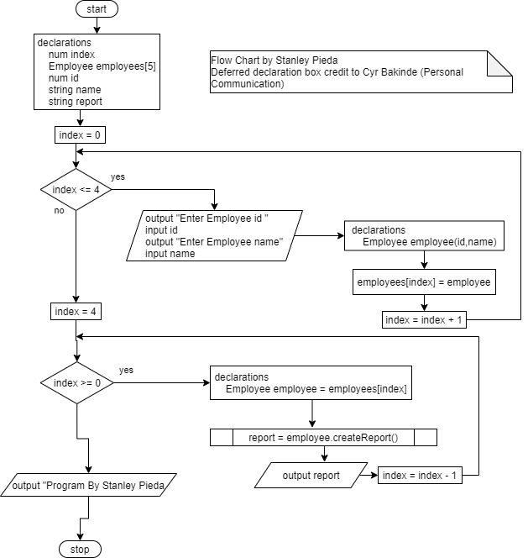

## Given the following hand-traces…

Input loop

|  |  |  |  |  |
| --- | --- | --- | --- | --- |
| Loop control variable | Should Continue | Outputs | Input Values | Array Index Value |
| 0 | Yes | Enter Employee id  Enter Employee name | 101  “One” | 0 |
| 1 | Yes | Enter Employee id  Enter Employee name | 102  “Two” | 1 |
| 2 | Yes | Enter Employee id  Enter Employee name | 103  “Three” | 2 |
| 3 | Yes | Enter Employee id  Enter Employee name | 104  “Four” | 3 |
| 4 | Yes | Enter Employee id  Enter Employee name | 105  “Five” | 4 |
| 5 | No |  |  |  |

Output loop

|  |  |  |  |
| --- | --- | --- | --- |
| Loop control variable | Should Continue | Output | Array Index Value |
| 4 | Yes | “Employee: 105, Five” | 4 |
| 3 | Yes | “Employee: 104, Four” | 3 |
| 2 | Yes | “Employee: 103, Three” | 2 |
| 1 | Yes | “Employee: 102, Two” | 1 |
| 0 | Yes | “Employee: 101, One” | 0 |
| -1 | No |  |  |

## Given the Screen Shot…

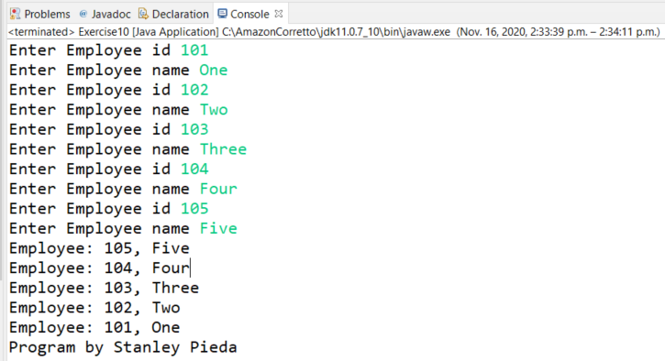

## Given the Java Source Code Files… (See Exercise10.java and Employee.java)

# Microsoft Word Document Format

See the template example (from exercise 01), suggested headings below:

Memory Map

**The only thing to pass in is the memory map within a MS Word document, hand-drawn memory maps that are photographed or scanned and then inserted as an image are acceptable.**

# Submission Requirements

* Upload your MS Word document by the due date. See Brightspace for due dates.
* Follow any additional submission requirements specified by your lab professor when submitting your homework.

# Grading (6 Points)

|  |  |  |  |
| --- | --- | --- | --- |
| Criteria | Missing / Poor (0) | Below Expectations (3) | Meets Expectations (6) |
| Memory Map | Missing, or poorly done, or student name not included in memory map. | Partly correct, may not have all references mapped correctly. | Correct, shows reference to array, references to Employee objects, with fields, String fields show references to Strings for names. |

# Archive: Sample Program Run (User inputs highlighted in yellow, bold font)

Enter Employee id **101**

Enter Employee name **One**

Enter Employee id **102**

Enter Employee name **Two**

Enter Employee id **103**

Enter Employee name **Three**

Enter Employee id **104**

Enter Employee name **Four**

Enter Employee id **105**

Enter Employee name **Five**

Employee: 105, Five

Employee: 104, Four

Employee: 103, Three

Employee: 102, Two

Employee: 101, One

Program by Stanley Pieda